Durham City Centre Accommodation
Properties highlighted in red are bookable through Durham Visitor Contact Centre. If you would like to use our accommodation booking service, or require any further assistance, please call us on 03000 262626. You can also e-mail us on visitor@thisisdurham.com or tweet us @moreDurham.

Castle View Guest House
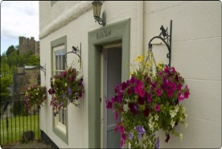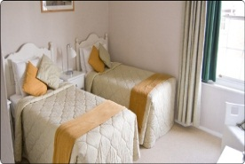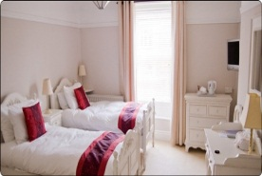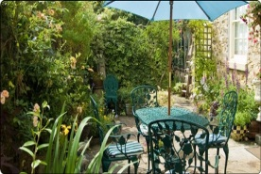

Address 4 Crossgate  Durham City  DH1 4PS | Telephone +44 0191 386 8852  Email castle_view@hotmail.com  Web http://www.castle-view.co.uk

Description Castle View Guest House is situated in the very heart of the cathedral city of Durham, just a short stroll away from the city’s amenities. This 250-year-old guesthouse is surrounded by picturesque riverside walks and spectacular views of the cathedral and castle. The guest house has recently been refurbished, and now features two new enlarged deluxe rooms with king sized beds and 40 inch flat screen TVs, hair driers tea and coffee etc. The guesthouse is an excellent base for exploring the city’s attractions which are all within walking distance including the stone cobbled streets which are filled with restaurants, pubs and cafes, leading to the magnificent cathedral. Within a 15-minute walk are the beautiful botanical gardens and the Gala Theatre. Guests are invited to use our small garden to the rear which is surrounded by a nature reserve and and which has many shaded walks and a meandering footpath route to the cathedral across the rarely discovered Prebends footbridge - made famous by the poem by Sir Walter Scott carved into it's ancient stonework.
Gradings
Grading | Date
Visit England Stars 4 | 1 January 2013
Prices
Unit Type | Min Price | Max Price | Comments | Price Basis
Single (En-Suite) | 70 | 80 | 2015 | Per room (breakfast included)
Double (En-Suite) | 100 | 120 | 2015 | Per room (breakfast included)
Twin (En-Suite) | 100 | 120 | 2015 | Per room (breakfast included)

Collingwood College
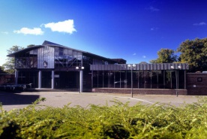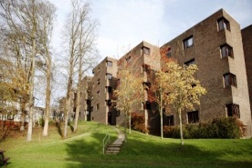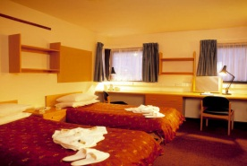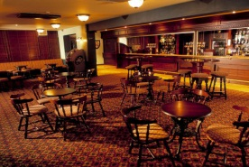

Address South Road  Durham City  DH1 3LT | Telephone +44 0191 334 5000  Email Cwd.reception@durham.ac.uk  Web http://www.dur.ac.uk/collingwood/

Description Collingwood has been welcoming guests since it was built in 1972. Situated in its own grounds only a short walk from the castle and cathedral and with the A1(M) and train station nearby, Collingwood is the perfect place to stay. There are over 200 en suite rooms including 16 twins and 9 which have been adapted for wheelchair users. Each has a shower, toilet, hand basin, tea/coffee-making facilities and radio alarm clocks. All rooms are serviced daily. Free on-site parking for cars and coaches. Gradings
Grading | Date
Visit England Stars 4 | 1 January 2013
Prices
Unit Type | Min Price | Max Price | Comments | Price Basis
Single Room | 35 | 35 | 2014/15 Dec-Jan | Per room (breakfast included)
Single (En-Suite) | 48 | 48 | 2014/15 Dec-Jan | Per room (breakfast included)
Twin (En-Suite) | 87.5 | 87.5 | 2014/15 Dec-Jan | Per room (breakfast included)
Single Room | 35 | 35 | 2015 Easter | Per room (breakfast included)
Single (En-Suite) | 48 | 48 | 2015 Easter | Per room (breakfast included)
Twin (En-Suite) | 87.5 | 87.5 | 2015 Easter | Per room (breakfast included)

Cuthberts Rest
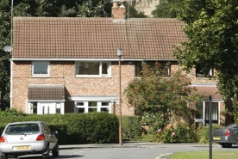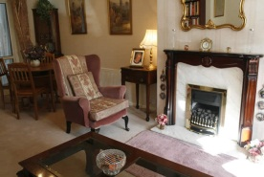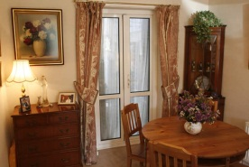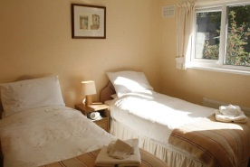

Address 42 Oswald Court  Durham City  DH1 3DJ | Telephone +44 0191 384 0405  Email  Web

DescriptionSmall, family-run, bed and breakfast establishment situated in the city, local amenities are easily accessible. Motorway and rail links are nearby. A warm, welcome and friendly environment awaits. TV, hair dryer and tea-making facilities in each room. An ironing service is available for a small charge. Central to all university colleges. Non-smoking. Varied breakfast menu.
Gradings
Grading | Date
Visit England Stars 3 | 1 January 2013
Prices
Unit Type | Min Price | Max Price | Comments | Price Basis
Single Room | 35 | 35 | 2014 | Per room (breakfast included)
Twin Room | 50 | 50 | 2014 | Per room (breakfast included)

Durham Castle
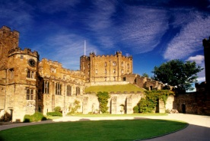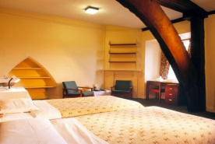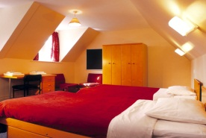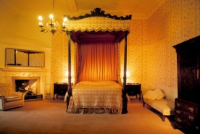

Address Palace Green  Durham City  DH1 3RW | Telephone +44 0191 334 4106  Email w.r.chambers@durham.ac.uk  Web http://www.durhamcastle.com

Description Durham Castle offers affordable university-style student accommodation, which is suited to the budget traveller looking for a unique place to stay. This 11thC castle is part of a World Heritage Site and has an excellent central location adjacent to Durham Cathedral. Our rooms are simply furnished, with a limited number having en suite bathroom facilities. A full English breakfast is included and will be served in one of our prestigious state rooms. In addition to this, at anytime during your stay, you are welcome to join one of our public guided tours on a complimentary basis.
Gradings
Grading | Date
Visit England Stars 4 | 1 January 2013
Prices
Unit Type | Min Price | Max Price | Comments | Price Basis
Single Room | 40 | 40 | 2014/15 Dec-Jan | Per room (breakfast included)
Twin Room | 77.5 | 77.5 | 2014/15 Dec-Jan | Per room (breakfast included)
Single (En-Suite) | 65 | 65 | 2014/15 Dec-Jan | Per room (breakfast included)
Double (En-Suite) | 195 | 195 | 2014/15 Dec-Jan | Per room (breakfast included)
Double (En-Suite) | 150 | 150 | 2014/15 Dec-Jan | Per room (breakfast included)
Double (En-Suite) | 87.5 | 98 | 2014/15 Dec-Jan | Per room (breakfast included)
Twin (En-Suite) | 98 | 98 | 2014/15 Dec-Jan | Per room (breakfast included)
Triple (En-Suite) | 146.5 | 146.5 | 2014/15 Dec-Jan | Per room (breakfast included)

Durham Marriott Hotel Royal County
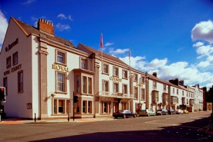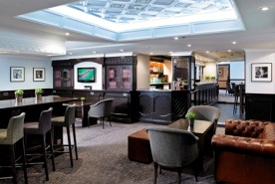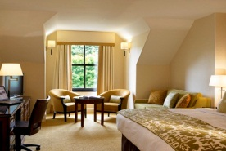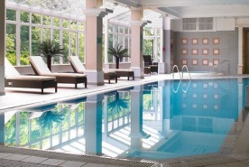

Address Old Elvet  Durham City  DH1 3JN | Telephone +44 0191 3866821  Email mhrs.xvudm.frontdesk@marriotthotels.com  Web http://www.durhammarriottroyalcounty.co.uk

DescriptionIf it’s the first time you’ve visited Durham, you’ll be pleasantly surprised by the warmth of our welcome. Durham Marriott Hotel Royal County is full of history and regal charm, yet with every modern facility you’d expect from one of the finest hotels in the area. Each of our beautifully appointed bedrooms and suites benefit from en-suite bathrooms and combine comfort and convenience with many offering views of the city or the River Wear. Newly Refurbished - Bar 1815 - Re-launching & re-naming our newly refurbished bar - 1815 - we are delighted to be open from 12.01pm - 7 days a week - offering a wide selection of international Tapas, Afternoon Teas, Cocktails and Pommery Champagne. The Leisure Club offers a relaxed and friendly setting to smooth away the stresses and strains of modern day life. Just 5 minutes from the A1(M) and 15 minutes walk from Durham Railway Station the hotel is located in the heart of Durham City sprinkled with ancient ruins, quaint shop-lined streets and numerous riverside walks.
Prices
Unit Type | Min Price | Max Price | Comments | Price Basis
Single (En-Suite) | 89 | 119 | 2015 | Per room (room only)
Double (En-Suite) | 99 | 119 | 2015 | Per room (room only)
Twin (En-Suite) | 99 | 119 | 2015 | Per room (room only)
Family (En-Suite) | 99 | 199 | 2015 | Per room (room only)

Durham Riverside Apartment
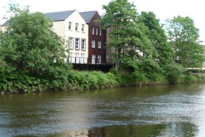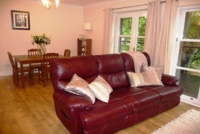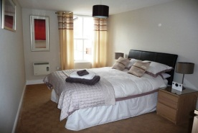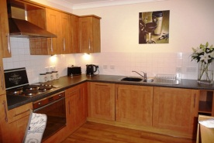

Address Flat 5  St Andrews Court  Durham City  DH1 3AH | Telephone +44 0780 960 1955  Email info@durham-riverside-apartment.com  Web http://www.durham-riverside-apartment.com

DescriptionThe apartment is situated in the heart of one of Britain's most historic and beautiful cities overlooking the river Wear in a quiet location. With views to be enjoyed through the French doors or from the decking area where you can sit to eat, enjoy the fresh air or just relax! A great location that is surrounded by many historic buildings, boutique shops, bars and restaurants. The ground floor has a fully secured door with a remote electronic lock. An internal hallway leads to a secure underground car park with an allocated parking bay accessible via a lift or stairs. The main living area consists of a lounge and dining table complete with LCD TV, Wifi and telephone. The kitchen is fully equipped with integral appliances. The ground floor has a toilet and wooden floors throughout. The 2 double bedrooms are spacious with the master bedroom enjoying en suite facilities, in addition is a separate bathroom.
Gradings
Grading | Date
Visit England Stars 5 | 1 January 2013
Prices
Unit Type | Min Price | Max Price | Comments | Price Basis
Apartment | 100 | 125 | 2014 | Per unit per night
Apartment | 100 | 125 | 2015 | Per unit per night

Farnley Tower
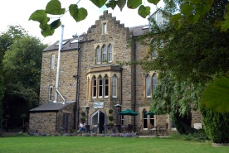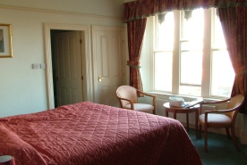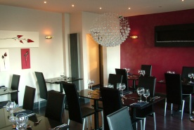

Address The Avenue  Durham City  DH1 4DX | Telephone +44 0191 375 0011  Email enquiries@farnley-tower.co.uk  Web http://www.farnley-tower.co.uk

DescriptionFarnley Tower is a prominent Victorian mansion, renowned for its architecture, gardens and stunning views over Durham Castle, Cathedral and surrounding countryside. Providing all the facilities you expect of a modern city centre hotel.
Gradings
Grading | Date
Visit England Stars 4 | 1 January 2013
Prices
Unit Type | Min Price | Max Price | Comments | Price Basis
Single (En-Suite) | 55 | 75 | 2014 | Per person (breakfast included)
Single (En-Suite) | 50 | 65 | 2014 | Per room (breakfast included)
Double (En-Suite) | 80 | 95 | 2014 | Per room (breakfast included)
Twin (En-Suite) | 80 | 95 | 2014 | Per room (breakfast included)
Family (En-Suite) | 100 | 140 | 2014 | Per room (breakfast included)

Franny Keay's B&B
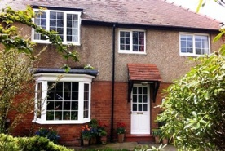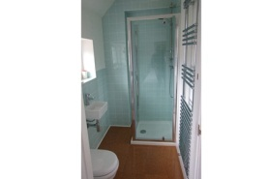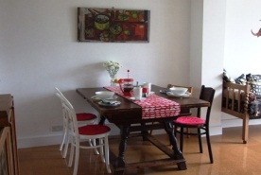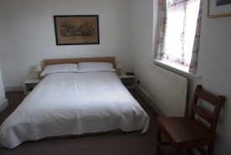

Address 9 Neville Square  Durham  DH1 3PY | Telephone 0191 384 1274  Email franceskeay123@gmail.com  Web

DescriptionFranny keay’s B&B is situated on a small tree lined square twenty minutes walk from the centre of Durham. We offer two bedrooms both with double beds, one en suit and the other with a private bathroom. Downstairs there is a comfortable sitting area within the large open plan kitchen area and also wifi access for guests. We are happy to cater for a variety of diets with due notice and offer choice of English, continental or vegetarian as standard. Our breakfast menu is mostly sourced from local producers and shops. There is usually a good selection of homemade seasonal jams, marmalade and breads.
Gradings
Grading | Date
Prices
Unit Type | Min Price | Max Price | Comments | Price Basis
Suite | 45 | 45 | 2014 | Per person (breakfast included)
Single (En-Suite) | 45 | 45 | 2014 | Per person (breakfast included)
Double (En-Suite) | 70 | 70 | 2014 | Per room (breakfast included)
Double - private bathroom | 70 | 70 | 2014 | Per room (breakfast included)

Harrys House
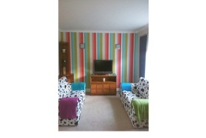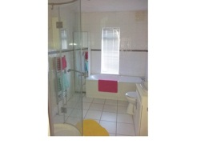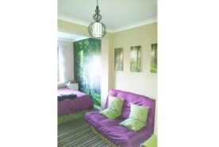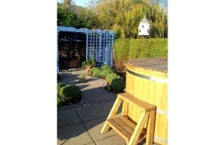

Address 42 High Street  Carrville  Durham  DH1 1AS | Telephone +44 0796 1889916  Email ludlowclaire@aol.com  Web http://www.harryshousedurham.co.uk/

DescriptionHarrys House Durham offers quality affordable self catering accommodation from 2-18 nights. Situated just 3 miles from Durham city centre, perfect for the A1M and A690 and within walking distance of Durham's Park and Ride. Large well appointed garden including wood fired hot tub. Well behaved pets welcome. We are pet friendly providing bowl, towels, toys and treats. Off street parking to the rear. The home has comfortable lounge with flat screen TV leading to spacious dining area and kitchen. Upstairs 3 bedrooms consist of a large woodland themed master suite, colourful twin and comfortable singe room. All bedding and fluffy towels are provided at no additional cost. For children we can supply safety gates, trravel cot and high chair as well as child friendly plates, beakers etc and a selection of games and DVDs. The property is fully equipped and includes a complimentary welcome basket. Harrys "A home from home".
Gradings
Grading | Date
Visit England Stars 3 | 10 December 2013
Prices
Unit Type | Min Price | Max Price | Comments | Price Basis
House | 70 | 70 | 2014 Low Season | Per unit per night
House | 70 | 100 | 2014 High Season | Per unit per night
House | 80 | 80 | 2015 Low Season | Per unit per night
House | 80 | 120 | 2015 High Season | Per unit per night

Hatfield College, Melville Building
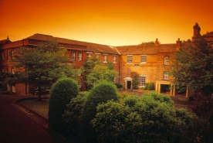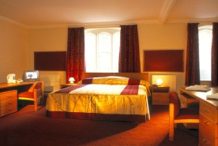

Address North Bailey  Durham City  DH1 3RQ | Telephone +44 0191 334 2633  Email hatfield.reception@durham.ac.uk  Web http://www.dur.ac.uk/hatfield.college/conferences_and_events/bed_and_breakfast_accommodation/

DescriptionHatfield College is situated in the heart of the City, in the shadow of the great Norman Cathedral and World Heritage Site, and on the banks of the River Wear. It is a few hundred yards from all the facilities and amenities that Durham has to offer. We can offer accommodation ranging from 2 star rated single standard and en suite rooms to 4 star rated executive en suite bedrooms (the only ones within the University). Limited car parking is available on site. Hatfield College's recently refurbished Melville Building provides 22 twin/double executive style en suite bedrooms and two family rooms. These rooms have been awarded the 'Visit Britain' 4 star rating, which confirms them as the best University accommodation available, moreover in a city centre location with its own parking. Single occupancy room rate available at £70 prpn.
Gradings
Grading | Date
Visit England Stars 4 | 1 January 2013
Prices
Unit Type | Min Price | Max Price | Comments | Price Basis
Double Room | 72 | 72 | 2014/15 Dec-Jan | Per person (breakfast included)
Double (En-Suite) | 98 | 98 | 2014/15 Dec-Jan | Per room (breakfast included)
Twin (En-Suite) | 98 | 98 | 2014/15 Dec-Jan | Per room (breakfast included)

Kingslodge Hotel

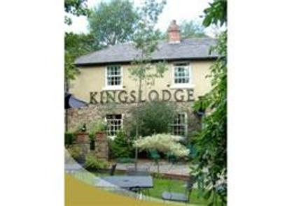
Address Flass Vale Waddington Street  Durham City  DH1 4BG | Telephone +44 0191 370 9977  Email kingslodgehotel@yahoo.co.uk  Web http://www.kingslodge.info

Description This modern stylish hotel provides comfortable, well-equipped accommodation. The Hotel restaurant Finbarr’s offers an imaginative menu of innovative dishes cooked with panache. Traditional bar and lounge, serves fine beers and wine along with quality pub food all with a friendly atmosphere.

Prices
Unit Type | Min Price | Max Price | Comments | Price Basis
Double (En-Suite) | 78 | 89 | 2015 | Per room (room only)
Twin (En-Suite) | 78 | 89 | 2015 | Per room (room only)
Single (En-Suite) | 63 | 67 | 2015 | Per room (room only)
Family (En-Suite) | 100 | 115 | 2015 | Per room (room only)

Moonlight Apartment and Durham Oasis Apartment
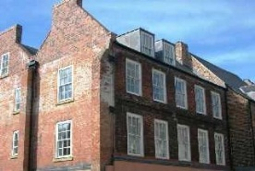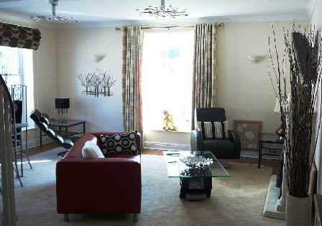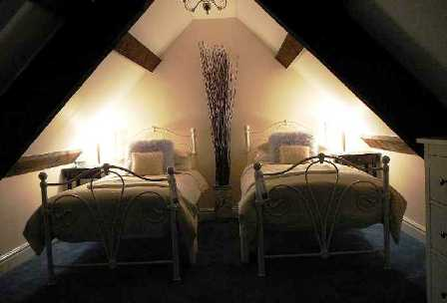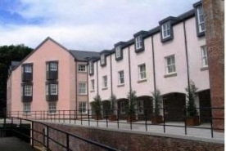

Address 32 St Andrew's Court  New Elvet  Durham City  DH1 3AH | Telephone +44 0191 378 7651  Email ray@moonlightapartment.co.uk  Web http://www.moonlightapartment.co.uk

Description Moonlight Apartment - Boutique-style luxury with cathedral, restaurants, cosmopolitan bars and shops right on the doorstep. Exceptional quality designer-inspired furnishings and sumptuous fabrics. Well equipped and stylish kitchen with microwave, fridge, freezer, dishwasher and washing machine. Unwind in the pristine bath or refresh yourselves in the separate shower with exclusive toiletries. As well as weekly rates below, nightly rates also available from £110-£160. Durham Oasis Apartment - Boutique-style luxury with cathedral, restaurants, cosmopolitan bars and shops right on the doorstep. Exceptional quality designer-inspired furnishings and sumptuous fabrics. Well-equipped and stylish kitchen with microwave, fridge, freezer, dishwasher and washing machine. Unwind in the pristine jacuzzi bath or refresh yourselves in the separate walk-in shower in the second bathroom with exclusive toiletries. Enjoy the plush towels, and curl up in the cosy robes. Complimentary wine, flowers, chocolate, snacks and supplies are included, as is your first morning's complimentary breakfast. Sink into the leather couch in the spacious lounge with wall-hung TV, DVD, quality sound system and relaxing mood lighting. Make yourself at home in the contemporary king size bed; there is an equally delightful single bedroom on the same level. Use of nearby gym, indoor pool, health and beauty facilities available by arrangement (at extra cost). Perfect for that romantic break but there's a phone and free wireless broadband if you need it.
Gradings
Grading | Date
Visit England Stars 5 | 1 January 2013
Prices
Unit Type | Min Price | Max Price | Comments | Price Basis
Apartment | 90 | 180 | 2014 | Per unit per night
Apartment | 90 | 180 | 2014 | Per unit per night

Radisson Blu Hotel Durham
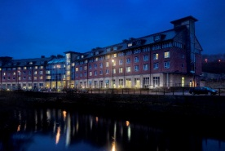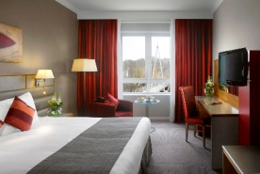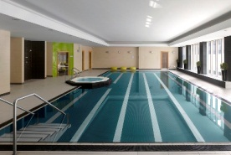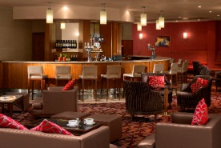

Address Frankland Lane  Durham City  DH1 5TA | Telephone +44 0191 372 7200  Email reservations.durham@radissonblu.com  Web http://www.radissonblu.co.uk/hotel-durham

DescriptionRadisson BLU introduces a stylish 1st class, full-service hotel to the city of Durham. Nestling on the banks of the River Wear, the new purpose-built hotel is the perfect choice for business and leisure travellers alike. Ideally located in the heart of the city, close to cultural attractions, shops, Durham Cathedral and the historic market place. Stay with Radisson BLU and experience a unique 'Yes I Can!' spirit and genuine hospitality. Offering 207 contemporary guest rooms including Standard Rooms, Junior Suites, Business Class Rooms and Presidential Suite. Other facilities include Pace Health Club with swimming pool, steam room, sauna, jacuzzi and gymnasium, Lime House Spa and the Filini Restaurant and Bar. The hotel is within walking distance of Durham Rail Station and has easy access from the A1 motorway. On site car parking is available.
Prices
Unit Type | Min Price | Max Price | Comments | Price Basis
Suite | 319 | 349 | 2014 | Per room (breakfast included)
Suite | 179 | 249 | 2014 | Per room (breakfast included)
Double (En-Suite) | 99 | 189 | 2014 | Per room (breakfast included)
Double (En-Suite) | 99 | 189 | 2014 | Per room (breakfast included)
Double (En-Suite) | 140 | 220 | 2014 | Per room (breakfast included)
Twin (En-Suite) | 99 | 189 | 2014 | Per room (breakfast included)
Family (En-Suite) | 99 | 189 | 2014 | Per room (breakfast included)

Sands House
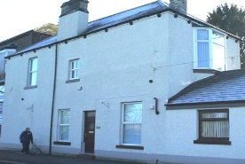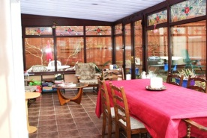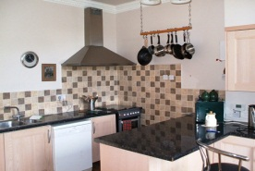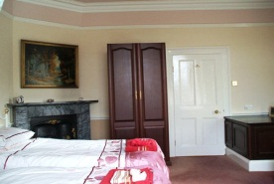

Address The Sands  Durham City  DH1 1JY | Telephone +44 07789 402470  Email gretahodgson@btinternet.com  Web http://www.sands-cottages.co.uk

Description Sands House is a two bedroom house situated near the river in a quiet area of the city and within easy walking distance of the city centre. The train and bus stations are only a 20/25min walk away as are the Durham Castle and Cathedral, Market Place and University buildings. There is a large garden to the rear of the house which guests have use of and which can be used to park 2 cars subject to height restriction of 1.8m. Street parking is available for larger vehicles. The ground floor consists of a lounge which is of a good size and has a sofa bed plus further seating, a TV and a 1.8m pool table. A large kitchen has a gas cooker, fridge/freezer, microwave and dishwasher. A table and 4 chairs are provided in the kitchen and a washing machine is provided in an under stairs cupboard off the kitchen. Drying facilities are provided in an outbuilding near to the parking area. To the rear of the property is a large conservatory which contains the main dining table with seating for 6 and other soft seating. A small wc is located in the conservatory. The first floor has 2 bedrooms and a bathroom. The double bedroom has en suite shower/wc and the other twin bedroom can also accommodate a camp bed or inflatable bed if required (provided on application). The bathroom has a bath with shower over bath and wc. The property is fully central heated and also has a stove which could be used in cold weather by arrangement. To the rear of the house is an established garden with several seating areas. Patio furniture is provided next to the conservatory for up to 6 people. Access to the rear of the house is across the garden and down 4 steps. To the front of the house access is level but is over a 200mm step into the front door. A bus service which accesses the Cathedral leaves from a coach park 300m away. This service can also be used to reach the bus and train stations.
Gradings
Grading | Date
Visit England Stars 3 | 1 January 2013
Prices
Unit Type | Min Price | Max Price | Comments | Price Basis
Cottage | 395 | 505 | 2014 Low Season | Per unit per week
Cottage | 505 | 505 | 2014 High Season | Per unit per week

St Aidan's College
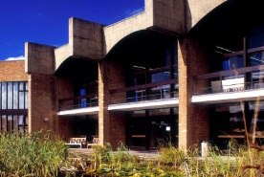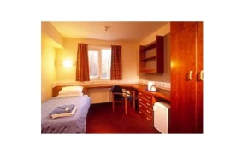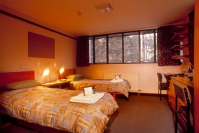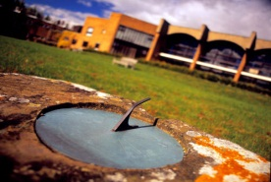

Address Durham University  Windmill Hill  Durham City  DH1 3LJ | Telephone +44 0191 334 5769  Email aidans.reception@durham.ac.uk  Web http://www.dur.ac.uk/st-aidans.college

DescriptionOverlooking the city of Durham and the magnificent Norman cathedral, St Aidan's is an ideal base from which to explore Northumberland, Cumbria and Weardale. Tourist attractions include Beamish Museum, Hadrian's Wall and Lindisfarne. En suite and standard accommodation is available, with facilities for the disabled during Self-catering houses also available. Bargain breaks for 2 and 3 nights. Half-price for children under 12. Discounts for group bookings.
Gradings
Grading | Date
Visit England Stars 3 | 1 January 2013
Prices
Unit Type | Min Price | Max Price | Comments | Price Basis
Single Room | 35.5 | 35.5 | 2014/15 Dec-Jan | Per room (breakfast included)
Twin Room | 62 | 62 | 2014/15 Dec-Jan | Per room (breakfast included)
Single (En-Suite) | 48 | 48 | 2014/15 Dec-Jan | Per room (breakfast included)
Twin (En-Suite) | 87.5 | 87.5 | 2014/15 Dec-Jan | Per room (breakfast included)

The Town House
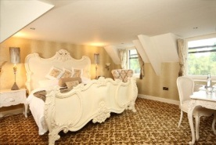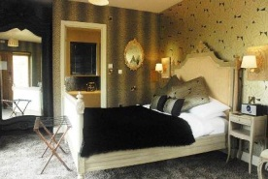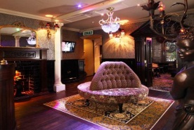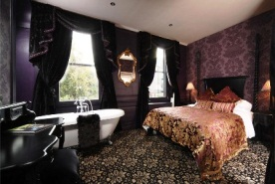

Address 34 Old Elvet  Durham City  DH1 3HN | Telephone +44 0191 384 1037  Email info@thetownhousedurham.co.uk  Web http://www.thetownhousedurham.co.uk

DescriptionA classic Georgian building from the outside...... step inside and prepare to be wowed. Choose The Town House, one of Durham city’s most beautiful hotel and restaurants. Nestled in historical and peaceful Old Elvet, a striking transformation of an elegant townhouse ideally located minutes away from the Cathedral & Castle and Durham’s vibrant night life. Once inside the decor exudes glamour, luxuriously decedent combined with an eclectic collection of antiques and paintings creating atmosphere and special ambience to completely relax and enjoy.
Gradings
Grading | Date
Visit England Stars 5 | 28 October 2014
Prices
Unit Type | Min Price | Max Price | Comments | Price Basis
Double (En-Suite) | 100 | 149 | 2014 | Per room (breakfast included)
Double (En-Suite) | 140 | 175 | 2014 | Per room (breakfast included)
Double (En-Suite) | 190 | 250 | 2014 | Per room (breakfast included)
Double (En-Suite) | 185 | 375 | 2014 | Per room (breakfast included)

The Victorian Town House
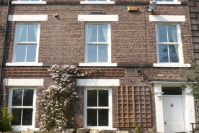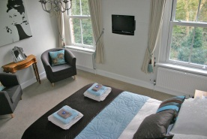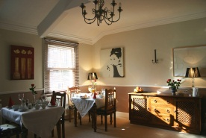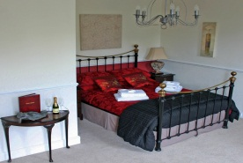

Address 2 Victoria Terrace  Durham City  DH1 4RW | Telephone +44 0191 370 9963  Email stay@durhambedandbreakfast.com  Web http://www.durhambedandbreakfast.com

DescriptionThe Victorian Town House is set in the heart of this historic university cathedral city and only a five minute walk from bus/train stations and city centre. It is conveniently situated for Beamish Museum, the Dales, Newcastle and Northumberland and well placed for the Great North Run, Freshers and Graduation Days. Enjoy a leisurely stroll around the riverbanks under the shadow of the Cathedral. Sample the new vibrant and fashionable bars and restaurants around the Gala Theatre and Millennium Square. The Town House itself is set in a peaceful Conservation Area overlooking a park and with views of the Cathedral from some rooms. Family, double and twin rooms are available, all furnished to a high standard. Rooms have TV, DVD and Freeview, as well as tea/coffee making facilities. A full English breakfast will set you up for the day. Private and on-street parking is available. Accessibility Statement can be provided on request. A warm welcome awaits you.
Gradings
Grading | Date
Visit England Stars 4 | 1 January 2013
Prices
Unit Type | Min Price | Max Price | Comments | Price Basis
Double (En-Suite) | 90 | 95 | 2014 | Per room (breakfast included)
Twin (En-Suite) | 85 | 85 | 2014 | Per room (breakfast included)
Family (En-Suite) | 95 | 120 | 2014 | Per room (breakfast included)
Double (En-Suite) | 90 | 95 | 2015 | Per room (breakfast included)
Twin (En-Suite) | 85 | 85 | 2015 | Per room (breakfast included)
Family (En-Suite) | 95 | 120 | 2015 | Per room (breakfast included)

Victoria Inn
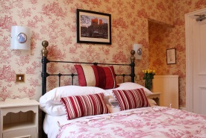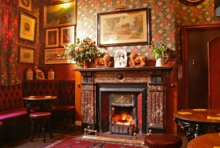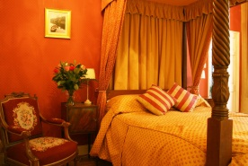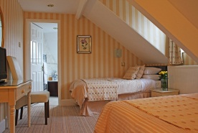

Address 86 Hallgarth Street  Durham City  DH1 3AS | Telephone +44 0191 386 5269  Email mwebstervictoria@gmail.com  Web http://www.victoriainn-durhamcity.co.uk

DescriptionFamily-run, Victorian public house with a friendly atmosphere offering reasonably priced, good quality en suite accommodation with free parking. The Victoria Inn provides 6 high quality bedrooms, all rooms are en suite with TV and tea and coffee making facilities. All of our bedrooms and bathrooms have been fully refurbished for 2012 and most bathrooms now include both a bath and shower. We are delighted to offer our guests free off street parking and we also have garages available on request. We are ideally situated for exploring the historic City of Durham with the spectacular World heritage site of Durham Cathedral and Castle only 4 minutes’ walk away. There are a wealth of attractions to visit locally, such as the world famous Beamish Open Air Museum, The Angel of the North and many more. If shopping is on your list of priorities then the North East has it all, from small market towns to the truly impressive Metro Centre. We cater for all tastes and styles and of course pockets! The nightlife in the North East has to be seen to be believed. Everyone is catered for, from small country pubs to real ale houses, to the largest nightclubs. You'll not be disappointed with what we have to offer. What better way to aid your recovery from a great night out than one of our "Hearty Breakfasts" - (The Good Pub Guide). CAMRA Pub of the Year 7 times. Free Wifi.
Gradings
Grading | Date
Visit England Stars 4 | 1 January 2013
Prices
Unit Type | Min Price | Max Price | Comments | Price Basis
Double (En-Suite) | 78 | 80 | 2014 | Per room (breakfast included)
Twin (En-Suite) | 78 | 80 | 2014 | Per room (breakfast included)
Family (En-Suite) | 85 | 85 | 2014 | Per room (breakfast included)
Double (En-Suite) | 78 | 80 | 2015 | Per room (breakfast included)
Twin (En-Suite) | 78 | 80 | 2015 | Per room (breakfast included)
Family (En-Suite) | 85 | 85 | 2015 | Per room (breakfast included)

27 Clements Wharf
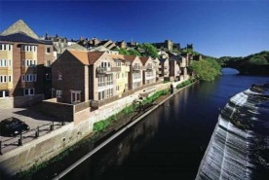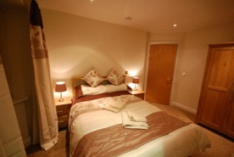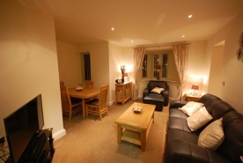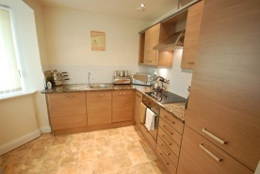

Address Back Silver Street  Durham City  DH1 3RP | Telephone +44 0191 384 0596  Email enquiries@toastlettings.com  Web http://www.toastlettings.com

DescriptionA beautifully positioned, newly built, modern, 2 bedroom, second floor, luxury apartment in the heart of Durham City Centre. Property briefly comprises Communal front entrance leading to private front entrance door to the apartment. Within the apartment there is entrance hallway, 2 bedrooms, main bedroom with en suite, main bathroom with bath and shower over, open plan lounge, kitchen and dining area. Bay window with views of the river Wear. It is impossible to get any more central than this. Secure parking, lift and video intercom telephone system are also provided. Situated at Back Silver Street, just behind Durham Market Place and within minutes’ walk of all of Durham City's amenities. The interesting Fowlers Yard workshops are next door which house niche enterprises such as artists’ studios and Hill Island microbrewery. A truly fantastic place to stay.
Gradings
Grading | Date
Prices
Unit Type | Min Price | Max Price | Comments | Price Basis
Apartment | 150 | 150 | 2014 | Per unit per night
Apartment | 150 | 150 | 2015 | Per unit per night

66 Claypath
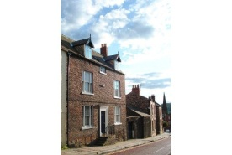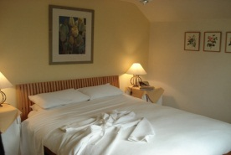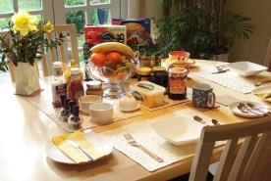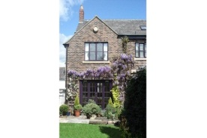

Address  Durham City  DH1 1QT | Telephone +44 0191 384 3193  Email richard@66claypath.co.uk  Web http://www.66claypath.co.uk

DescriptionA Grade II listed Georgian town house with a delightful secluded garden in the heart of Durham city. Comfortable rooms are well furnished and beautifully decorated. Quality breakfasts are freshly prepared to order. This bed and breakfast is close to the city centre, a short walk from the Market Place, the Castle, Cathedral, riverside paths and The Gala Theatre. Some of Durham's best restaurants and pubs are within easy walking distance. Ideally located for exdploring not just the city of Durham but all the North East has to offer. You can be assured of a warm and friendly welcome. We believe No 66 Claypath is ideally located for exploring not just the city of Durham but all that the North East has to offer.
Gradings
Grading | Date
Prices
Unit Type | Min Price | Max Price | Comments | Price Basis
Double Room | 60 | 80 | 2014 | Per room (breakfast included)
Double - private bathroom | 80 | 80 | 2014 | Per room (breakfast included)
Double Room | 60 | 80 | 2015 | Per room (breakfast included)
Double - private bathroom | 80 | 80 | 2015 | Per room (breakfast included)

College of St Hild & St Bede
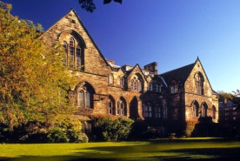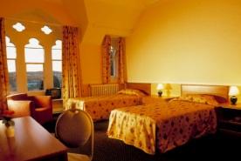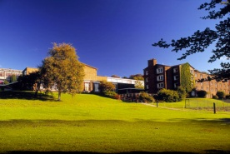

Address St. Hild's Lane  Durham City  DH1 1SZ | Telephone +44 0191 334 8568  Email hildbede.college@durham.ac.uk  Web http://www.dur.ac.uk/hild-bede/

DescriptionThe College of St Hild and St Bede offers a beautiful location in the heart of Durham City with easy access by road, rail and air. It offers Accommodation - bed and breakfast en suite, Conferencing - day and overnight packages and Special Events - a range of banqueting options. It has one of the largest halls in the city plus an additional 20 plenary meeting rooms. A unique Edwardian former chapel is available for important events. Relax in a modern newly refurbished bar. Tailored packages and services are available for groups with excellent catering and competitive pricing. The range of accommodation spans 20 acres. Access to libraries and computing facilities can be arranged. The College is open for day meetings and events for 50 weeks of the year. Residential accommodation is available during March, April and from July to September. Also 5 guest rooms are available throughout the year.
Gradings
Grading | Date
Visit England Stars 3 | 1 January 2013
Prices
Unit Type | Min Price | Max Price | Comments | Price Basis
Single Room | 40 | 40 | 2014 | Per room (breakfast included)
Single (En-Suite) | 48 | 48 | 2014 | Per room (breakfast included)
Twin (En-Suite) | 87.5 | 87.5 | 2014 | Per room (breakfast included)
Twin - private bathroom | 80 | 80 | 2014 | Per room (breakfast included)
Single Room | 40 | 40 | 2015 | Per room (breakfast included)
Single (En-Suite) | 48 | 48 | 2015 | Per room (breakfast included)
Twin (En-Suite) | 87.5 | 87.5 | 2015 | Per room (breakfast included)
Twin - private bathroom | 80 | 80 | 2015 | Per room (breakfast included)

Durham YHA
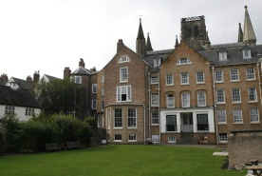

Address St Chad's College  University of Durham  18 North Bailey  Durham City  DH1 3RH | Telephone +44 0191 334 3358  Email chads@dur.ac.uk  Web http://www.dur.ac.uk/StChads

Description Superb location in historic college building adjacent to the Cathedral.
Gradings
Grading | Date
Visit England Stars 2 | 1 January 2013
Prices
Unit Type | Min Price | Max Price | Comments | Price Basis
Single Room | 25 | 25 | 2015 Winter | Per person (breakfast included)
Twin Room | 25 | 25 | 2015 Winter | Per person (breakfast included)
Single Room | 25 | 25 | 2015 Spring | Per person (breakfast included)
Twin Room | 25 | 25 | 2015 Spring | Per person (breakfast included)
Single Room | 25 | 25 | 2015 Summer | Per person (breakfast included)
Twin Room | 25 | 25 | 2015 Summer | Per person (breakfast included)

Premier Inn Durham City Centre
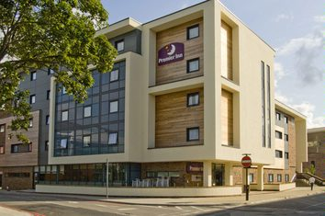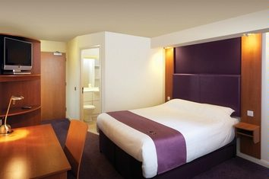

Address Freemans Place  Walkergate  Durham City  DH1 1SQ | Telephone +44 0871 527 8338  Email durhamcitycentre.pi@premierinn.com  Web http://www.premierinn.com/en/hotel/DURBAR/durham-city-centre

Description With three Premier Inns in and around Durham City Centre you will be spoilt for choice. Choose between a city centre location, Pity Me, 3 miles from the city centre or Belmont which is only a mile away. The choice is yours. Premier Inn Durham City Centre A great city centre location, this Premier Inn is conveniently located for amenities and attractions including historical markets, the Cathedral, Castle, Gala theatre, as well as various bars and restaurants. Conveniently located for Durham train station. Our Durham City Centre Premier Inn has everything you'd expect, incredibly comfy beds in every room and an integrated restaurant serving a mix of traditional and contemporary dishes. Premier Inn Durham East - Belmont Industrial Estate, Broomside Park, Durham City DH1 1GG Ideally situated for both business and leisure guests. For business this hotel is near to Belmont business park. Located within easy reach of the A1(M). For shops and local amenities Durham city centre is only 1 mile away. Our Durham East Premier Inn has everything you'd expect, incredibly comfy beds in every room and for modern contemporary dining, visit our Table Table restaurant. Premier Inn Durham North - Arnison Retail Centre, Pity Me, Durham DH1 5GB For shops and local amenities Arnison retail centre is only a 5 minute walk. Durham city centre is only 3 miles away. Conveniently located for Durham train station. Local attractions include Durham County Cricket Club, Beamish and Diggerland. Our Durham North Premier Inn has everything you'd expect, incredibly comfy beds in every room, an onsite Brewers Fayre restaurant serving great value pub favourites and a Fun Factory play area for children.
Gradings
Grading | Date
Budget Hotel | 10 September 2013
Budget Hotel | 31 January 2008
Prices
Unit Type | Min Price | Max Price | Comments | Price Basis
Double (En-Suite) | 39 | 100 | 2014 | Per room (room only)
Twin (En-Suite) | 39 | 100 | 2014 | Per room (room only)
Family (En-Suite) | 39 | 100 | 2014 | Per room (room only)
Double (En-Suite) | 39 | 100 | 2015 | Per room (room only)

St Chads College

Address 18 North Bailey  Durham City  DH1 3RH | Telephone +44 0191 334 3358  Email chads@dur.ac.uk  Web http://www.dur.ac.uk/chads/

Description St Chad's College is set on a dramatic site in the shadow of Durham Cathedral. Beyond the gardens, the land falls away into the wooded gorge of the River Wear which flows round this high peninsula, once the citadel of the Prince Bishops. The College fronts onto North Bailey, a medieval street that traces the spine of the peninsula southwards from the Market Place to Prebends Bridge. Our central location makes St Chad's the ideal base for exploring the city and surrounding countryside. Attractions within easy driving distance include the Bowes Museum, Hadrian's Wall and the North Yorkshire Moors. Accommodation is situated in one of our historic houses which are far older than their Georgian frontages suggest. Rooms are tastefully decorated; many rooms are en suite or have private facilities. Available university vacations - dates from college. Breakfast is served in the college dining-hall. A choice of English or Continental breakfast is always available. Tea and coffee-making facilities. Rooms contain original features. Gardens overlook the River Wear. Bamburgh, Alnwick and Lindisfarne easily accessible by car. Visit Holy Island and the beautiful Northumbrian Coast.
Gradings
Grading | Date
Visit England Stars 3 | 1 January 2013
Prices
Unit Type | Min Price | Max Price | Comments | Price Basis
Double Room | 60 | 60 | 2015 Easter | Per person (breakfast included)
Single Room | 35 | 35 | 2015 Easter | Per room (breakfast included)
Twin Room | 60 | 60 | 2015 Easter | Per room (breakfast included)
Single (En-Suite) | 40 | 40 | 2015 Easter | Per room (breakfast included)
Double (En-Suite) | 75 | 75 | 2015 Easter | Per room (breakfast included)
Double (En-Suite) | 75 | 75 | 2015 Easter | Per room (breakfast included)

St Johns College
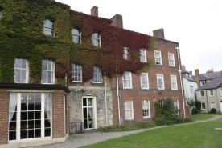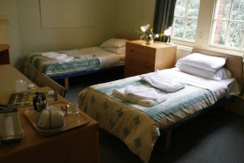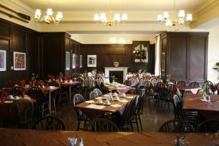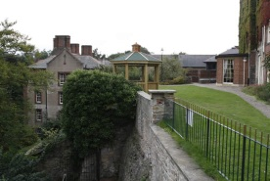

Address 3 South Bailey  Durham City  DH1 3RJ | Telephone +44 0191 334 3877  Email s.l.hobson@durham.ac.uk  Web http://www.durham.ac.uk/st-johns.college

DescriptionSt John's is located at the heart of the ancient city of Durham, opposite the cathedral and within the Castle Bailey wall in an area now designated a World Heritage Site. It is one of the oldest colleges in Durham. Consisting of a row of inter-linked Georgian houses perched between the cathedral and the River Wear, St John's is a maze of corridors and idiosyncratic rooms overlooking the river valley. Former occupants include the widow of Dean Whittingham, translator of the Geneva Bible (quoted by Shakespeare), and the Bowes-Lyon and Eden families. A regular visitor was Alice Liddell - the inspiration for Lewis Carroll's Alice in Wonderland. Family rooms available - accommodating families of 3 or 4. Please contact college directly for special deals
Gradings
Grading | Date
Visit England Stars 3 | 1 January 2013
Prices
Unit Type | Min Price | Max Price | Comments | Price Basis
Single Room | 33 | 33 | 2014 Summer | Per person (breakfast included)
Twin Room | 60 | 60 | 2014 Summer | Per room (breakfast included)
Single Room | 34 | 34 | 2015 Summer | Per person (breakfast included)
Twin Room | 60 | 60 | 2015 Summer | Per room (breakfast included)

Sylvan House
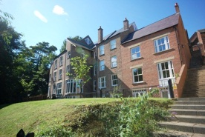

Address 6 Sylvan House  St Helens Well  Durham City  DH1 4DB | Telephone +44 0191 3840596  Email enquiries@toastlettings.com  Web http://www.toastlettings.com

DescriptionA beautifully presented, newly built, modern, 2 bedroom, ground floor, luxury apartment in the heart of Durham City Centre. Property briefly comprises Communal front entrance leading to private front entrance door to the apartment. Within the apartment there is entrance hallway, 2 bedrooms, one with “Jack and Jill” style doorway to main bathroom, open plan lounge, kitchen and diner with double doors leading out to private rear courtyard which leads up to communal grassed area. Situated on the banks of the River Wear, with green riverbank views, it does not have the appearance of being so centrally located, but It is impossible to get any more central than this. Situated on what many consider to be the most desirable street in Durham City. Benefiting from intercom system, secure garaged parking, outside area including private yard and communal grassed area this is a very special place to stay. Please note there are a number of stairs leading down to this apartment, about 4 flights and no lift. This property may not be suitable for visitors with mobility issues.
Prices
Unit Type | Min Price | Max Price | Comments | Price Basis
Apartment | 100 | 100 | 2014 | Per unit per night
Apartment | 100 | 100 | 2015 | Per unit per night

The Bridge
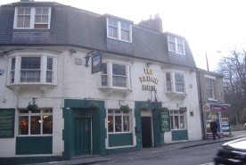

Address 40 North Road  Durham City  DH1 4SE | Telephone +44 0191 386 8090  Email Bridgehotel.durham@btconnect.com  Web http://www.bridgehoteldurham.com

DescriptionCentrally located welcoming pub with home-cooked food and traditional cask ales served daily. Within walking distance of the train station and bus station. Food served all day. We offer a homely and friendly service.
Gradings
Grading | Date
Visit England Stars 3 | 1 January 2013
Prices
Unit Type | Min Price | Max Price | Comments | Price Basis
Double (En-Suite) | 60 | 60 | 2014 | Per room (breakfast included)
Twin (En-Suite) | 60 | 60 | 2014 | Per room (breakfast included)

